**ENR 161 Fall 2017 Chapter 4 Homework**

Name _________________________________________________ Grade ______________

Step 1:

Watch the Video Entitled, **ENR161 Ch04 HW F16**, this video is stored on the M drive at MCC or on youtube.com.

Step 2:

Complete the questions and problems below.

1. How can an Excel user determine what all the proper unit abbreviations are for the convert function?

2. List the steps for assigning a name to a cell so that the name is only valid in a single worksheet.

3. If a cell contains the formula, **=sin(A5)** , what units does Excel assume A5 is in?

4. The Vlookup function has three arguments Vlookup(arg1, arg2, arg3). Define what arg1, arg2, arg3 represent and how the function works.

5. List the steps for solving for V1 using Goal Seek in the Projectile Motion II worksheet.

**Grade for Questions (0-10)** ______________________

**Problem Stamp or Grade**

**Pages 179-182, Syntax Worksheet _________**_____________

Name the worksheet **Syntax**.

Complete the operations presented in Figures 4.1, 4.2, 4.3, 4.4, 4.5, 4.6, 4.7 on the same worksheet. Label all operations to clearly document the components of the sheet as shown below.

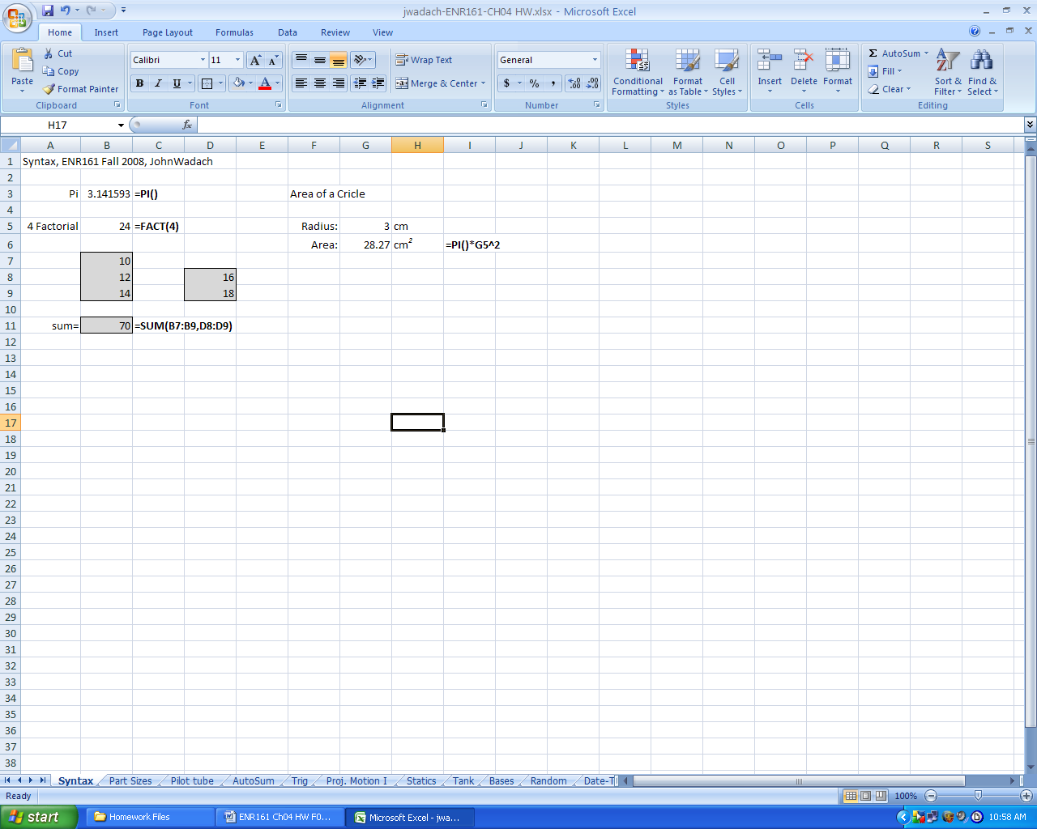

**Pages 182-184, Part Size Worksheet _________**_____________

1. Name the worksheet **Part Size**.

2. Follow the instructions for figures 4.9 and 4.10 to create the worksheet below.

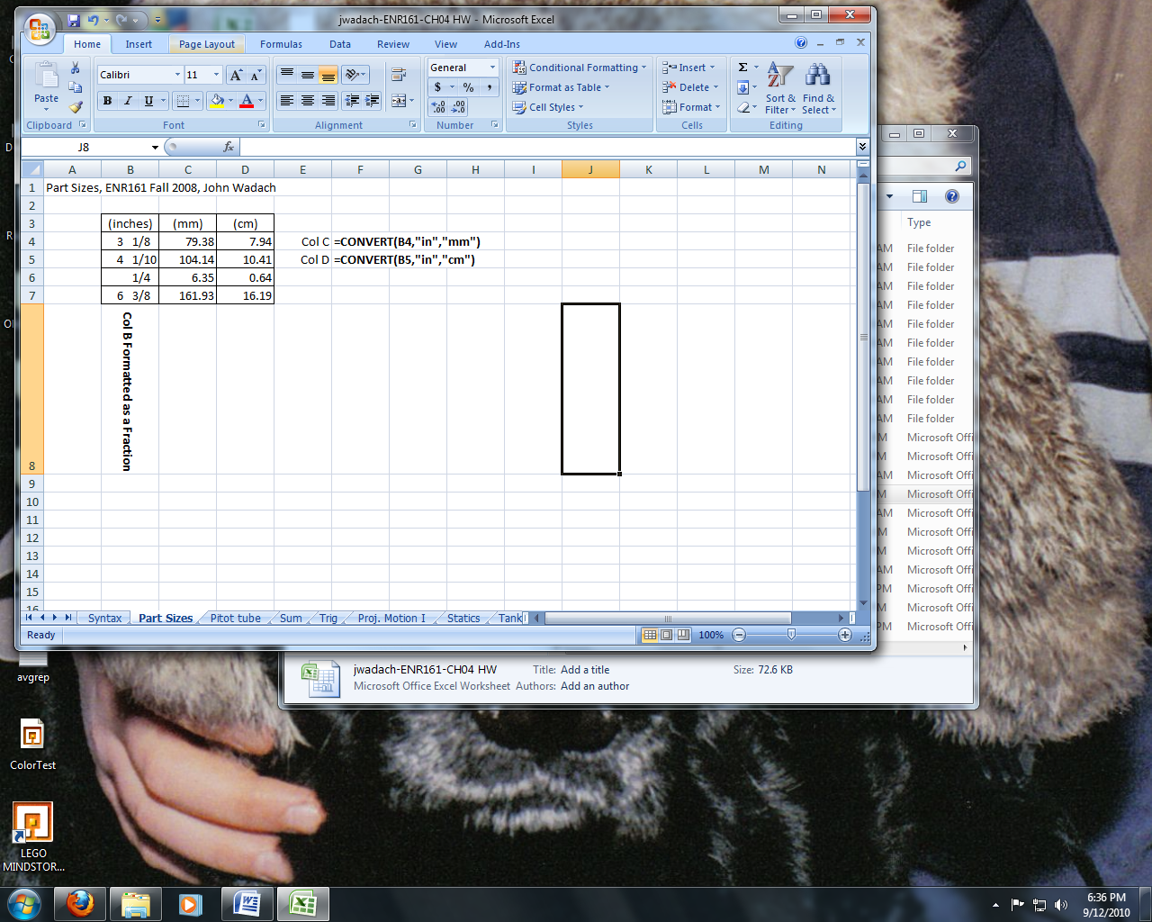

**Pages 185-186, Pitot Tube Worksheet _________**_____________

1. Name the worksheet **Pitot Tube**.

2. Create the worksheet for figure 4.14 but name cell C4 **Pdiff** and cell C6 **Density**.

3. Use the copy and paste functions and then type an apostrophe before the equal sign to display the formulas used. Your final worksheet should appear as below.

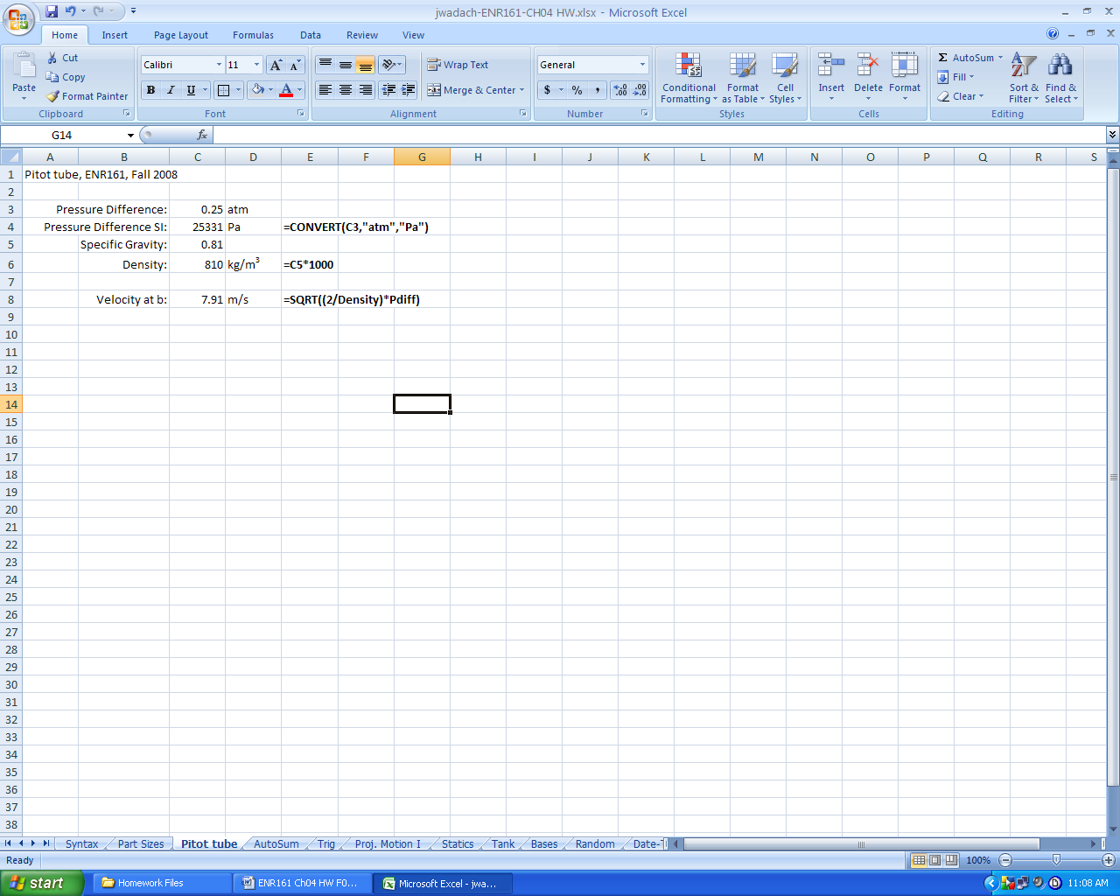

**Pages 187-188, Sum Worksheet _________**_____________

1. Name the worksheet **Sum**.

2. Follow the directions for figures 4.15-4.17 to create the worksheet shown below.

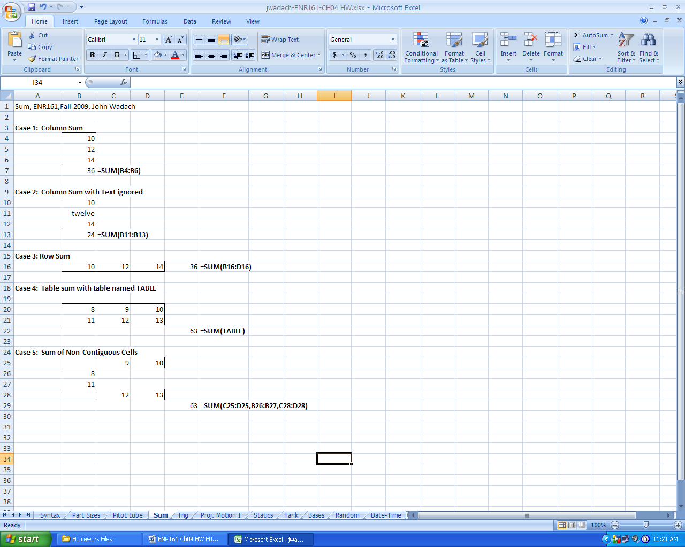

**Pages 190-191, Trig Worksheet**  ______________________

1. Name the worksheet **Trig**.

2. Use the information presented in figures 4.22 and 4.23 to create the worksheet below.

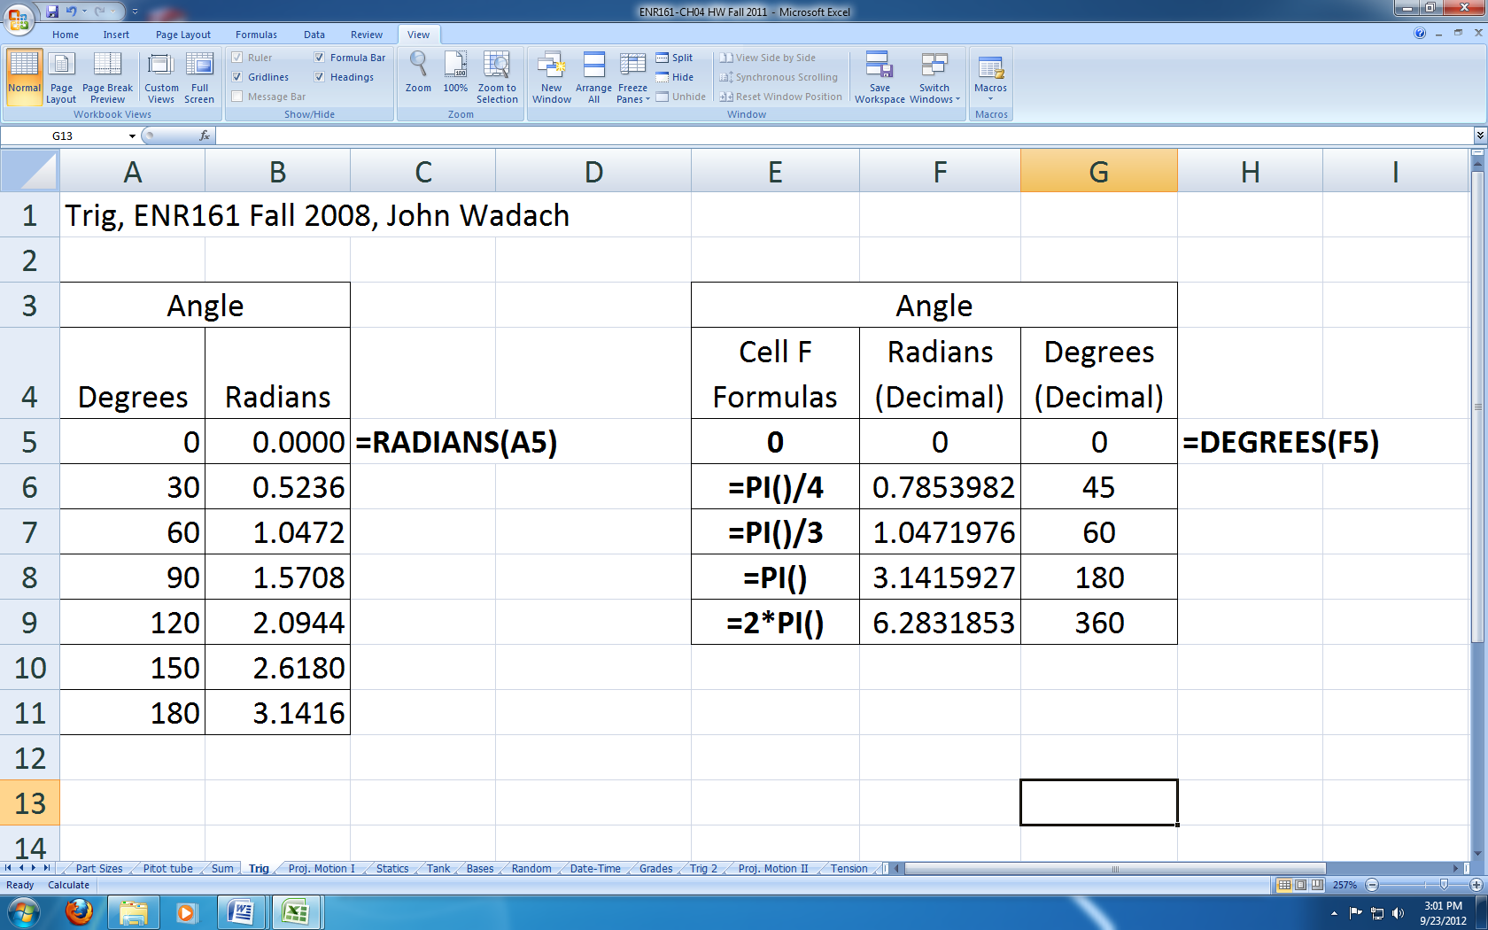

**Pages 192-194, Proj. Motion I Worksheet**  ______________________

1. Name the worksheet **Proj. Motion I**.

2. Use named cells and present the data and formulas of the Projectile Motion I application as shown below.

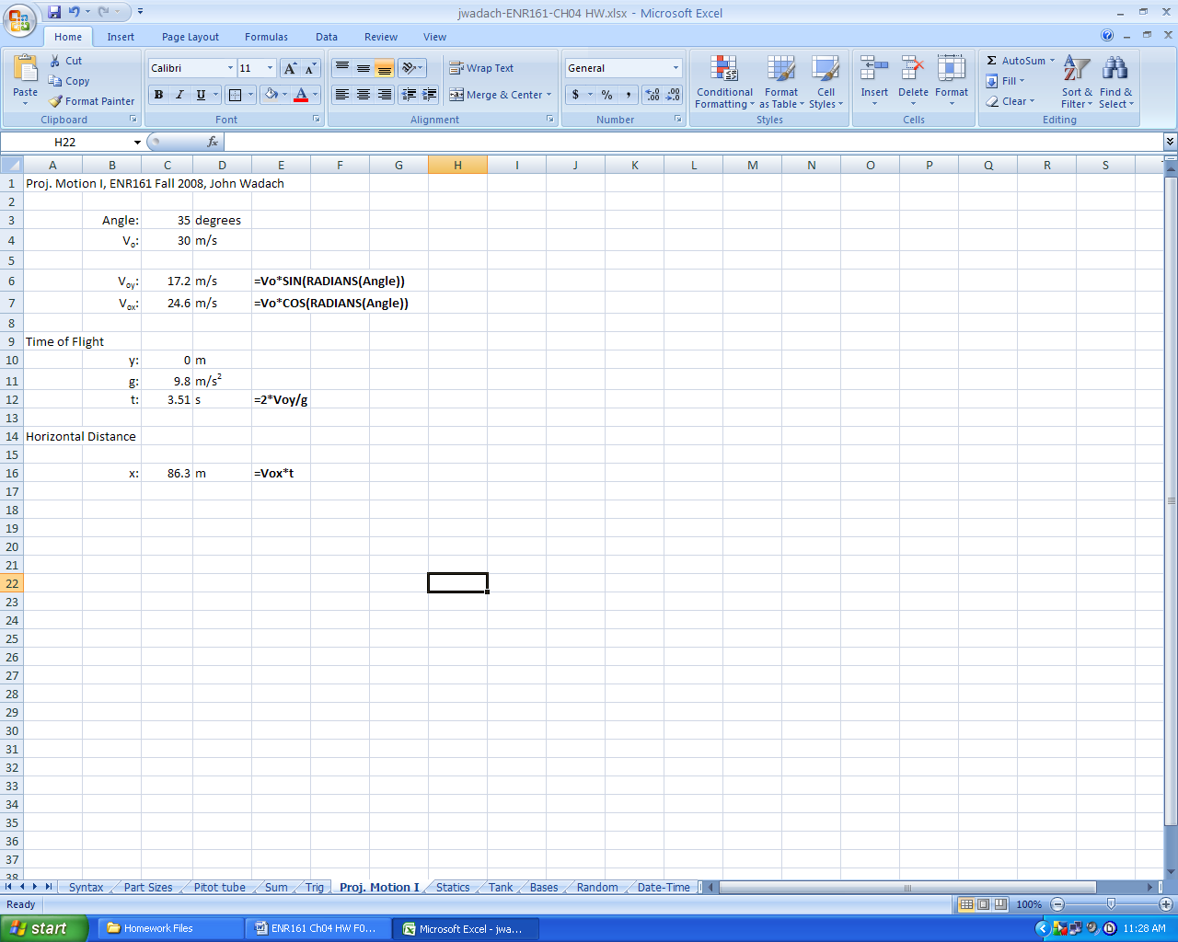

**Pages 195-198, Statics Worksheet**  ______________________

1. Name the worksheet **Statics**.

2. Use named cells and present the data and formulas of the Statics application as shown.

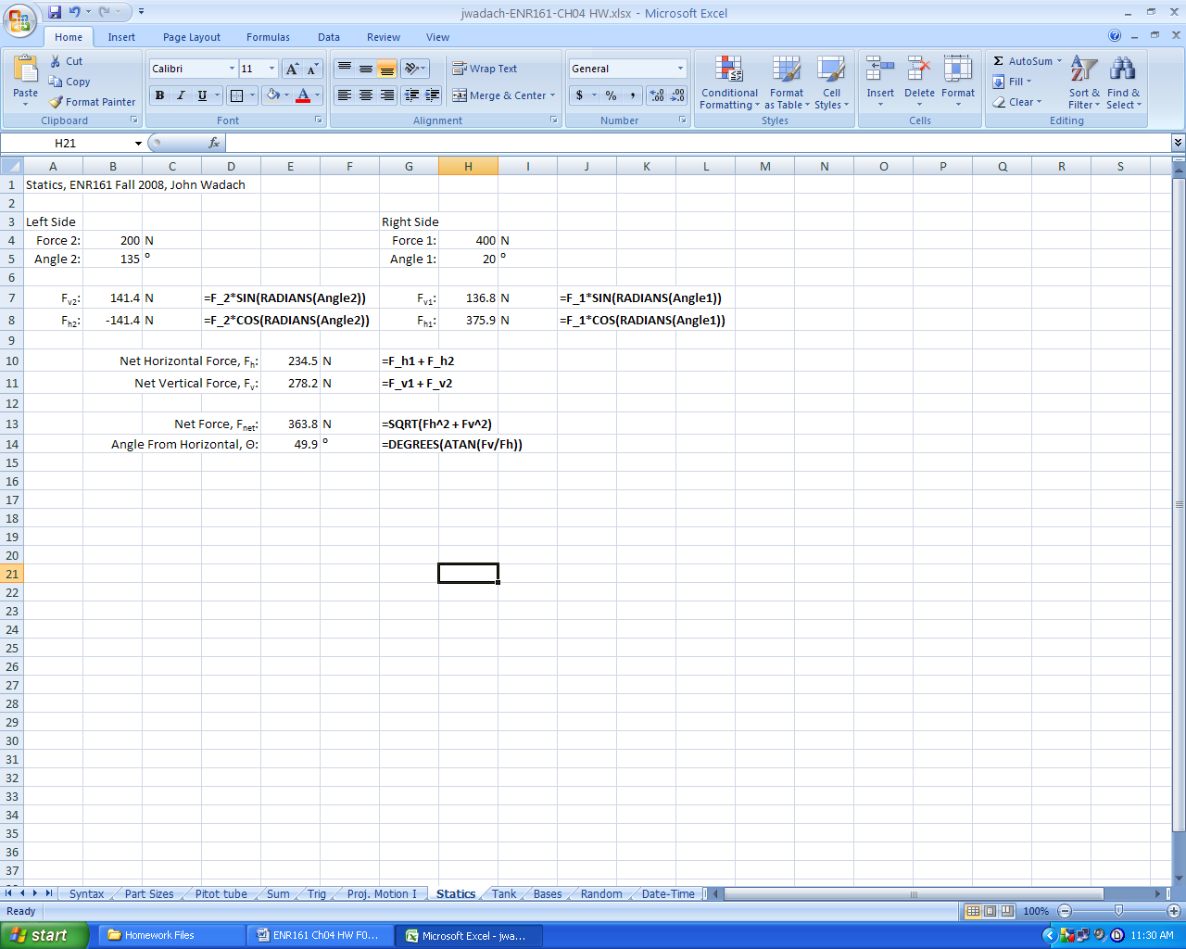

**Page 199-200, Tank Worksheet**  ______________________

1. Name the worksheet **Tank**.

2. Use named cells and present the data and formulas of figure 4.38 as shown below.

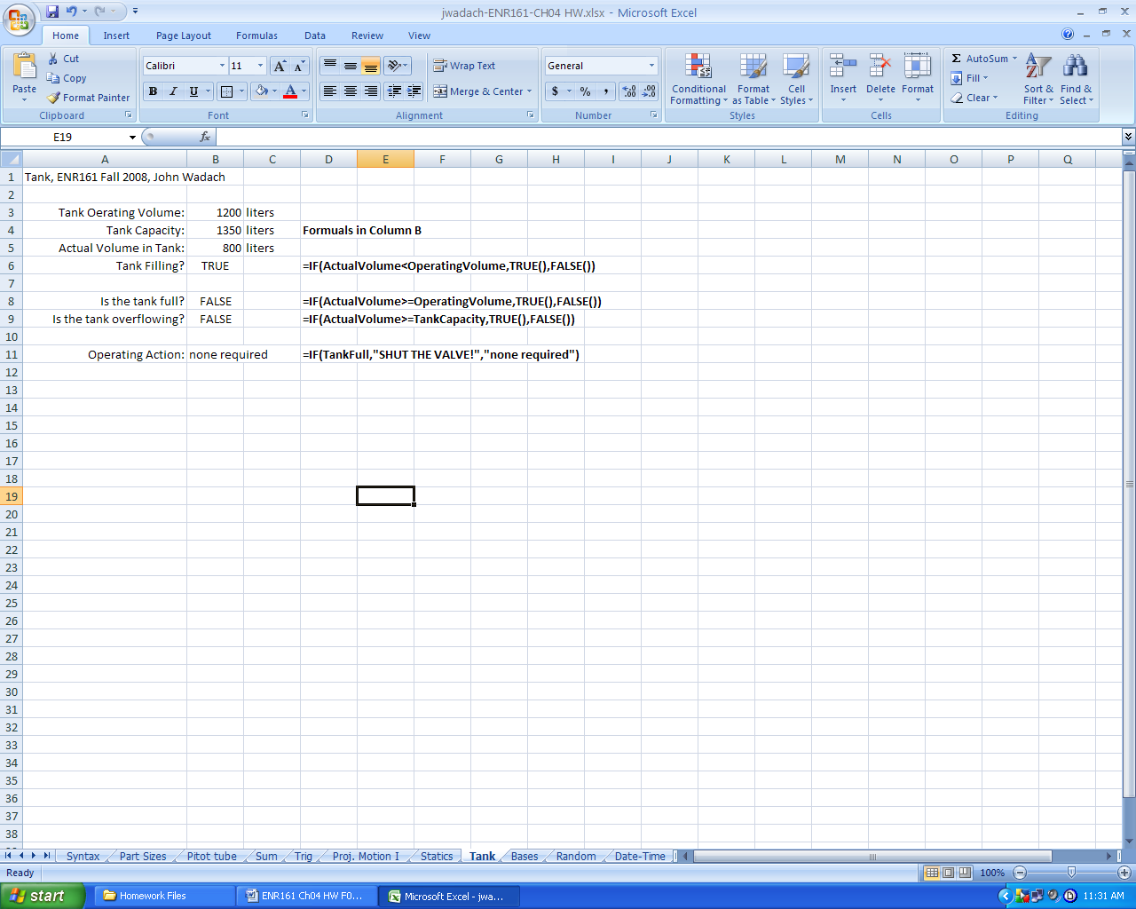

**Page 203, Bases Worksheet**  ______________________

1. Name the worksheet **Bases**.

2. Present the data and formulas of figure 4.41 as shown below.

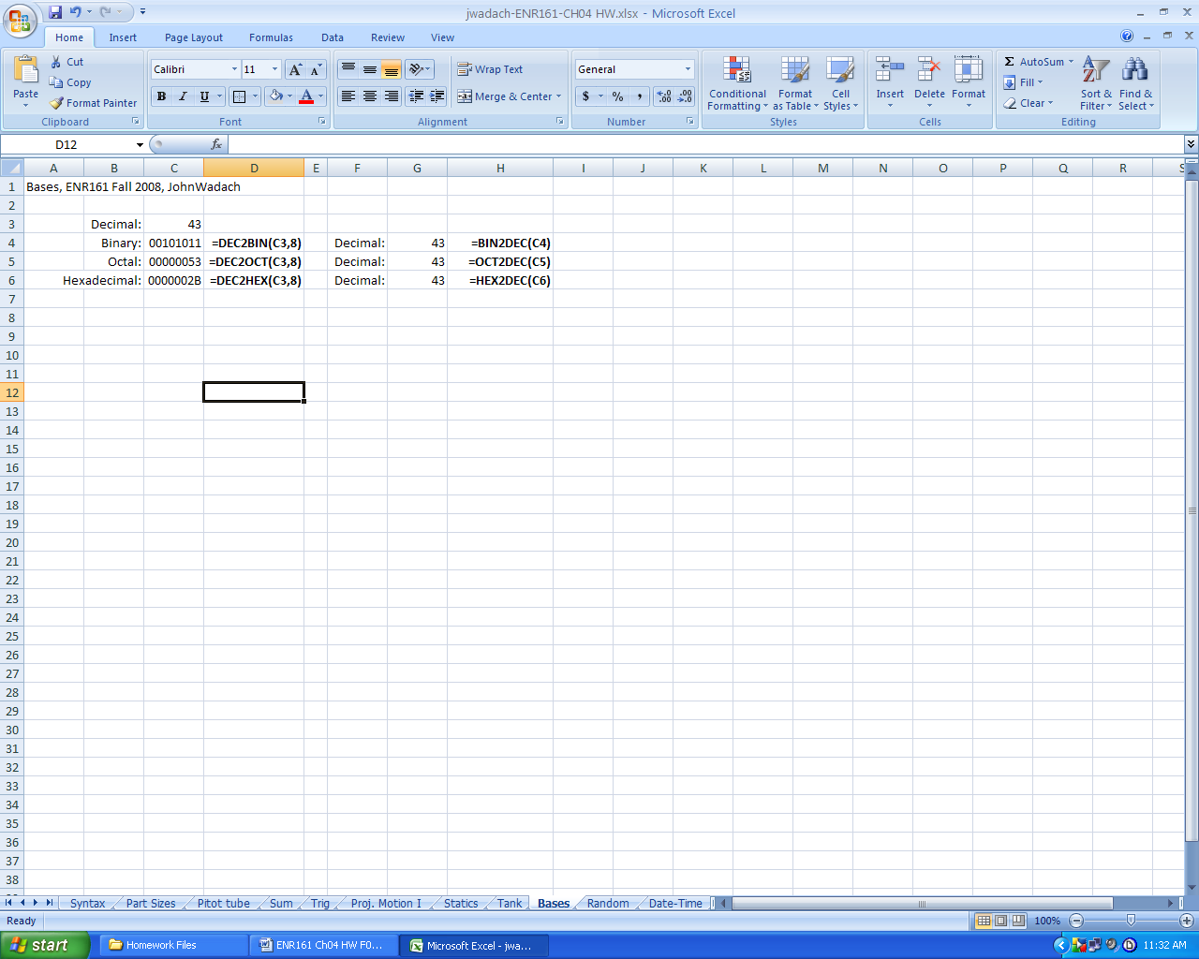

**Pages 203-207, Random Worksheet**  ______________________

1. Name the worksheet **Random**.

2. Follow the directions for adding in the Analysis ToolPak and creating 100 random numbers (25 in each in rows A,B, C, and D) along with the average and standard deviation. Present your values as shown below.

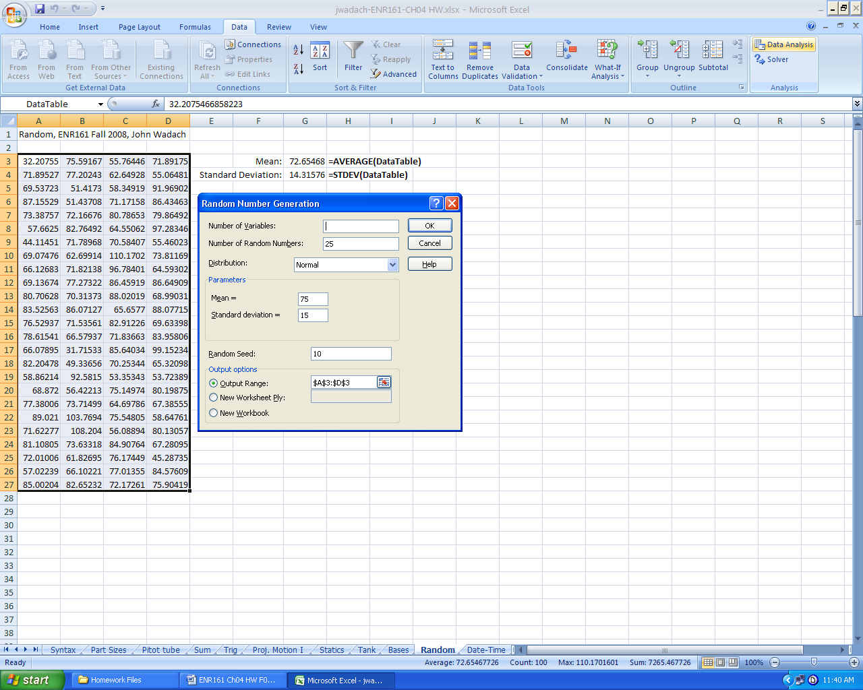

**Pages 208-211, Date-Time Worksheet**  ______________________

1. Name the worksheet **Date-Time**.

2. Use the date and time functions described on pages 208-211 to create the worksheet below.

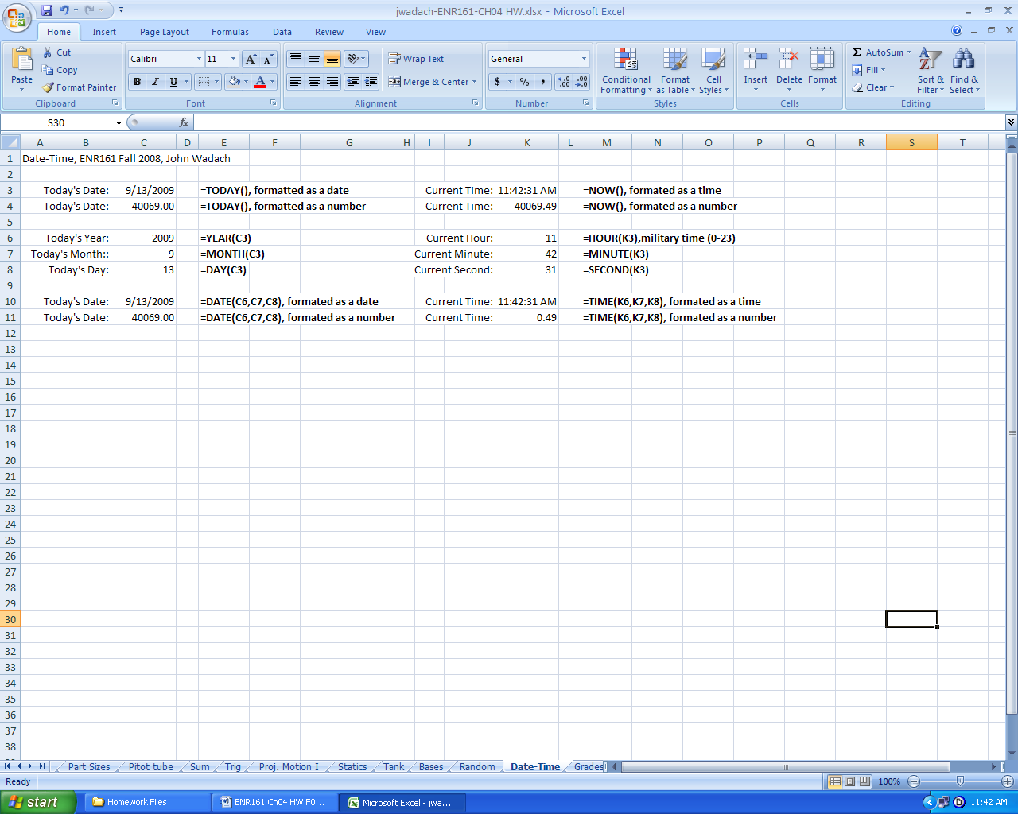

**Pages 211-212, Grades Worksheet**  ______________________

1. Name the worksheet **Grades**.

2. Create the worksheet shown below and be sure to name the shaded values in the Table **GradeTable**.

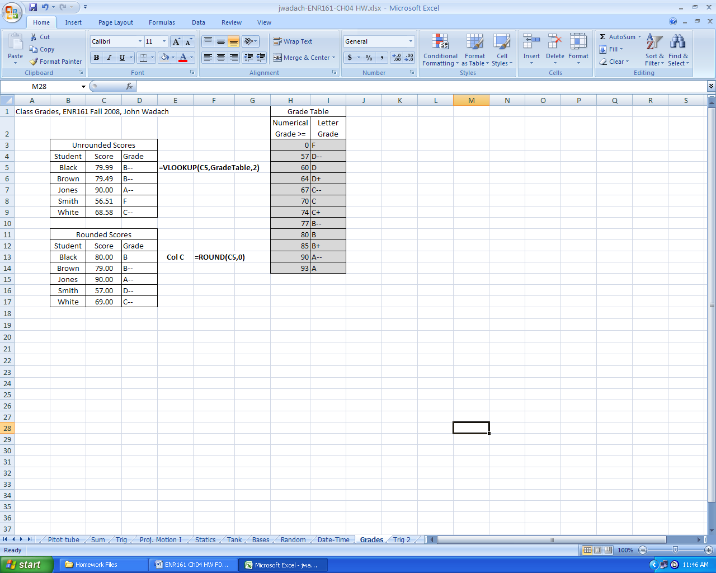

**Pages 218-219, Problem 4.1, Trig 2 Worksheet**  ______________________

1. Name the worksheet **Trig 2**.

2. Create the worksheet shown below.

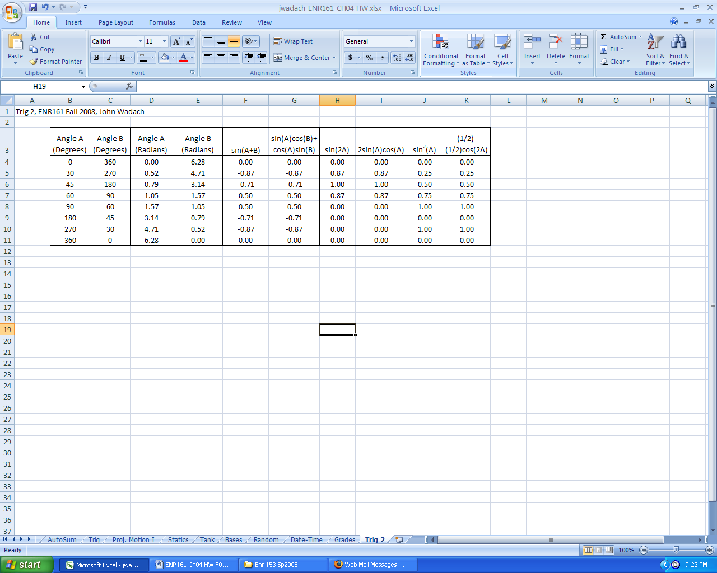

**Page 219, Problem 4.3, Proj. Motion II Worksheet**  ______________________

1. Name the worksheet **Proj. Motion II**.

2. Note that the methods shown in the Proj. Motion I worksheet must be modified as shown below because the ball does not enter the basket at the same height that he was launched from. Note that Y is now the vertical distance from where the shot is released to the basket. Hint: All distances must be in meters. You may find the Convert function helpful.

3. Set up your worksheet as shown below. At this point the value of V1 is only a guess. In step 4 we will use Goal Seek to find the correct value.

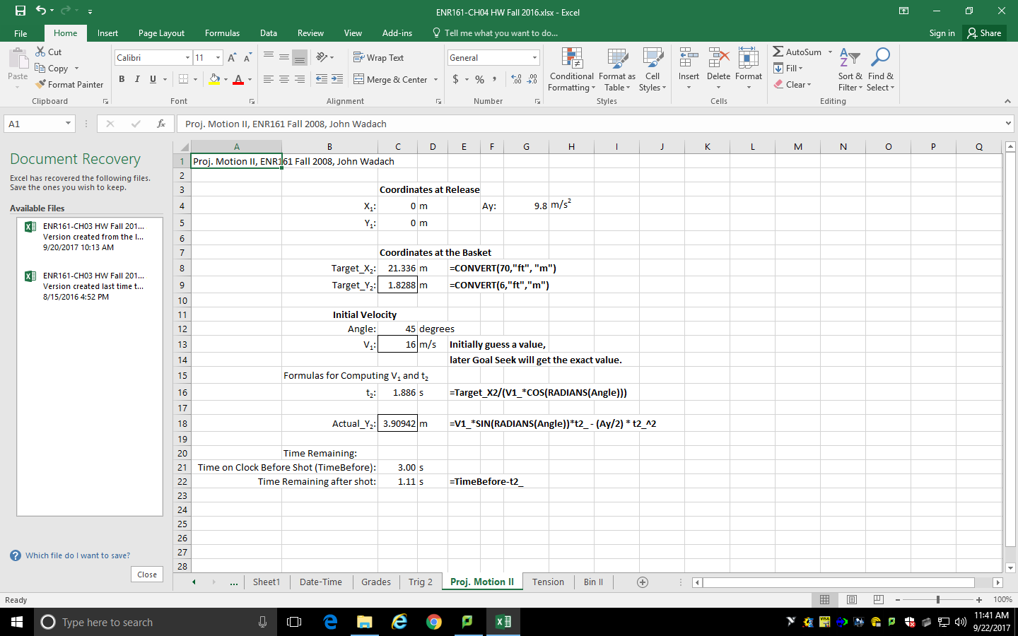

4. Locate the Goal Seek function in the **Data/What If Analysis/Goal Seek** menu.

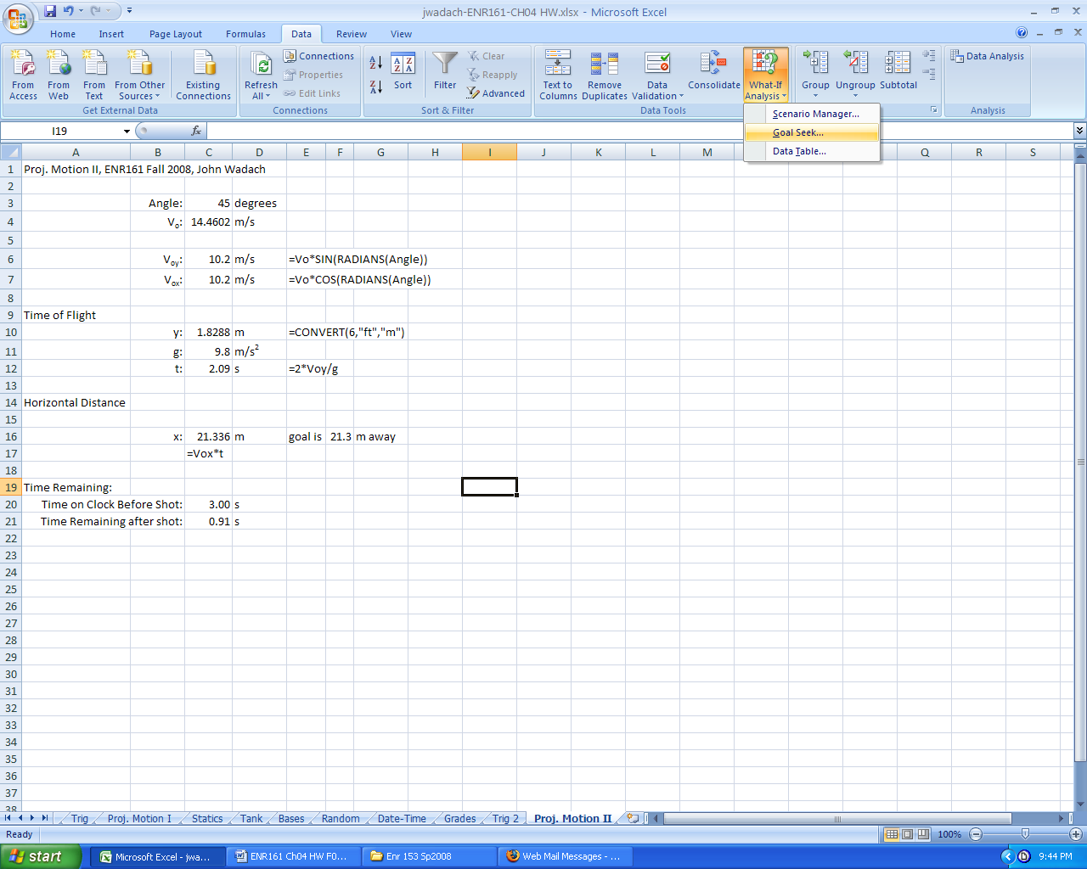

5. Use the Goal Seek with the inputs shown. Goal Seek will keep changing the value of V1 until the Actual Y2 value is equal to the Target Y2 value.

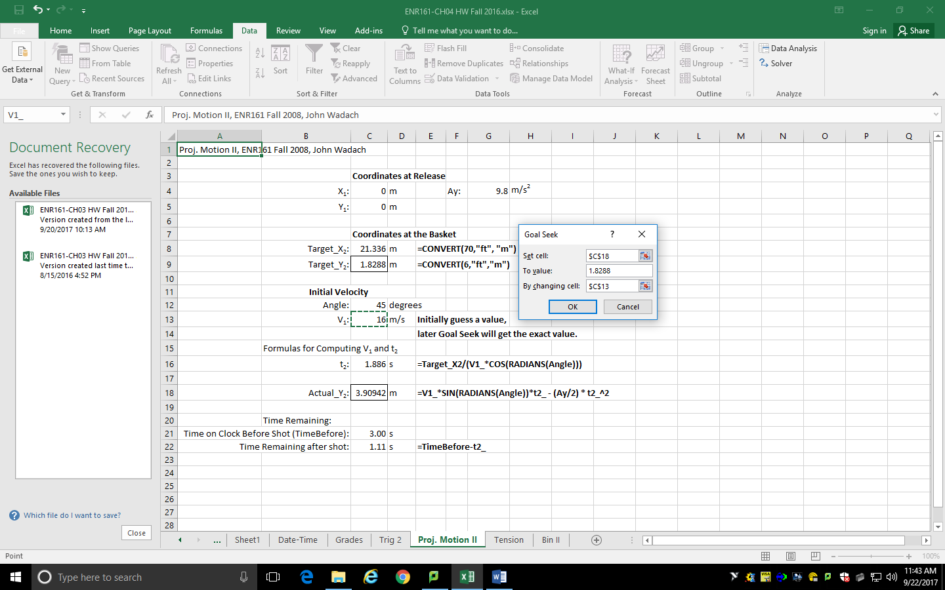

**Page 220, Problem 4.5, Tension Worksheet**  ______________________

1. Name the worksheet **Tension. Perform calculations for both 30⁰ and 50⁰ on your worksheet.**

2. If you wish to use variable names that were previously used in the workbook, you will need to use the Define Name function.

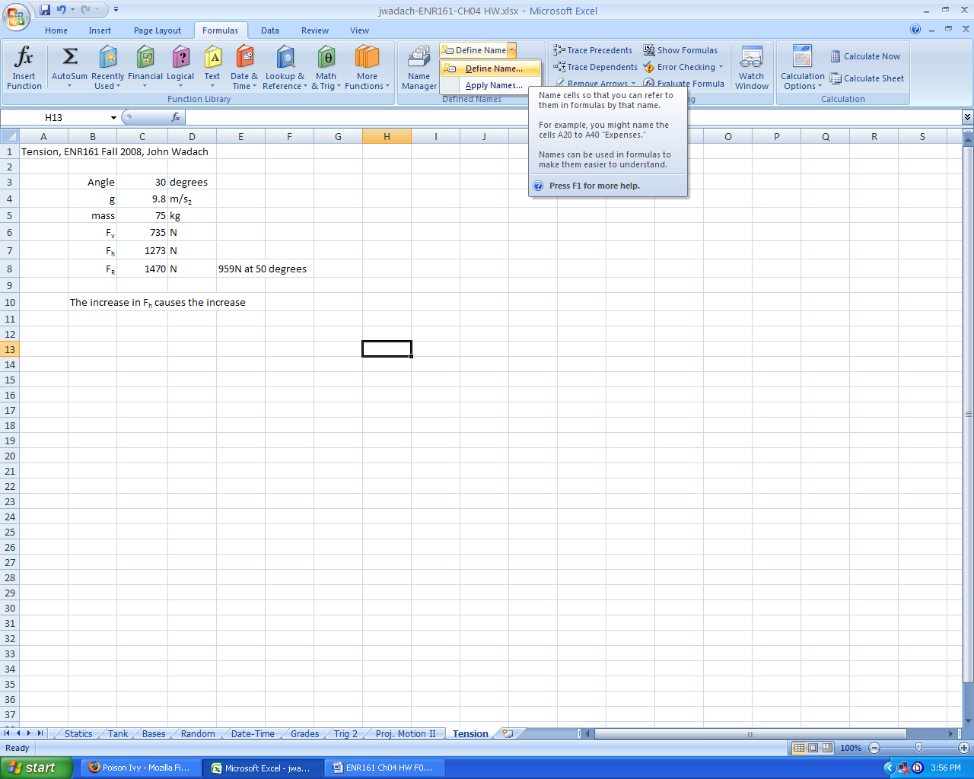

3. When defining a name to be used for only one worksheet in an Excel workbook select the **Scope** to be only for the **Tension** worksheet.

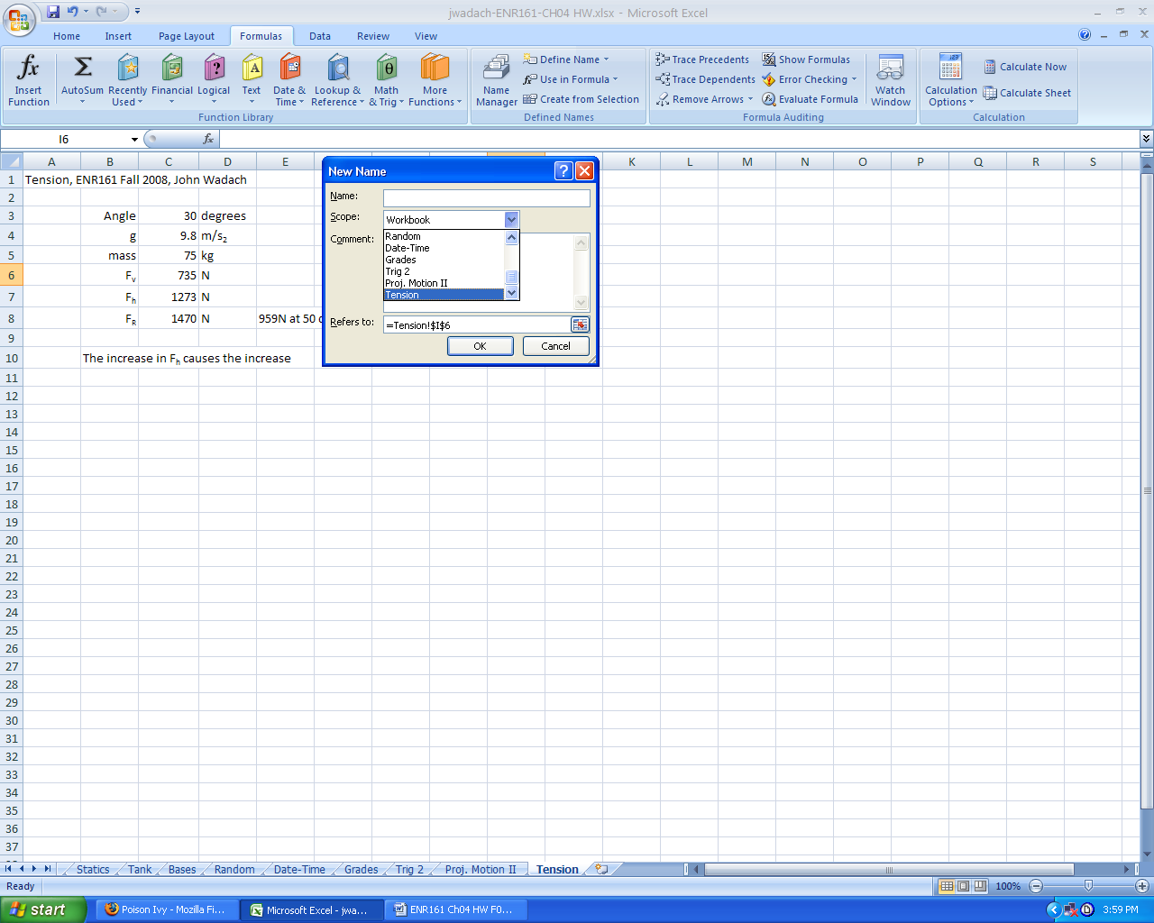

4. Note that Fv=mg where m is the mass in kg and g=9.8 m/s2.

**Page 222, Problem 4.9, Bin II Worksheet**  ______________________

1. Name the worksheet **Bin II.**

2. Use named cells for hcone, rcylinder, and Angle (Θ).

3. Note that **rh = h*tan(Θ)** when **h < hcone**. If **h >= hcone , rh = rcylinder**.

Notes